
Keeping it Green: December 2025
Red Dragon ReUse returns ahead of the holidays

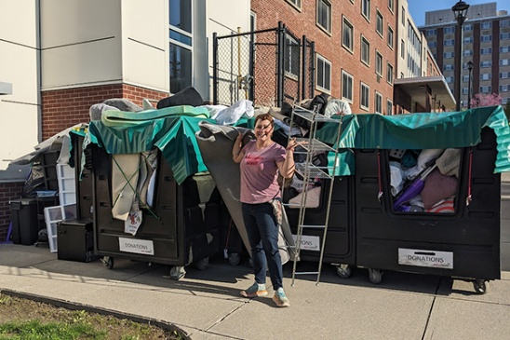
For the first time we will be hosting the Red Dragon Donation collection at the end of the fall semester. On campus students can drop off any donations in bins in their Residence Halls from December 4th through December 15th. Off-campus students can drop off any donation directly to Cortland ReUse (check their website about donations details).
Please be mindful about what you are donating and that they are in good enough shape to be used by another person without too much repair work. Accepted donations include:
- Unopened nonperishable food. Donated food will first help restock the SUNY Cortland Cupboard food pantry. Students should not include any open or perishable items in the donations.
- Clothing, linen and textiles. Some clothes may be sold at ReUse, with the rest given to Thrifty Shopper and other groups that serve the local homeless population. Bedding and pillows go to Mutual Aid.
- Foam bed toppers. This item is a uniquely common one at SUNY Cortland compared to other places ReUse collects from
- Other items, including: printer paper, pens, scissors, and other office supplies; sheets, blankets, towels; lamps, small furniture, and other household items; electronic equipment

Voices for sustainability: Green Reps share their passions
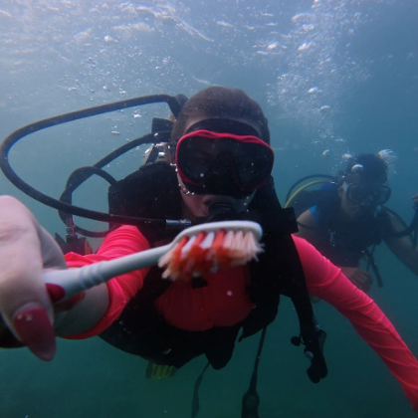
As the Green Reps celebrate their first full year back on campus, the students reflect on their experiences working on campus and other sustainability related topics.
- Coral reefs: why we must save them, before it’s too late – Luna Demski
- A visit to the Cortland recycling facility – Ava Brandon
- Mind the gap – Fiona Joss
- Why I decided to be a Green Rep – Tiana Schelble
- Government shutdowns impact on the National Park Service – Caroline Rossi
- Sustainable architecture on Cortland campus – Nuala Seabrook
- Climate change and the impact it has on New York state snowfall – Kat Wilburn
- Why reusable? Reasons why opting for reusable items is the better decision – Brianne Leak
Are you interested in sustainability? Apply to be a Green Rep for the Spring 2026 semester!

SUNY Cortland earned a spot in the Princeton Review’s annual Guide to Green Colleges

Cortland chosen for green campus partnership grant
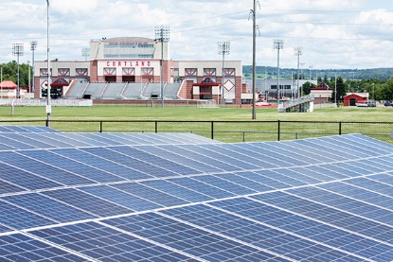
SUNY Cortland was one of eight campuses to be awarded the Second Nature Catalyst Grant. The $3,500 award will help the campus measure the success of its environmental programs – specifically regarding scope 3 emissions and Red Dragon ReUse.

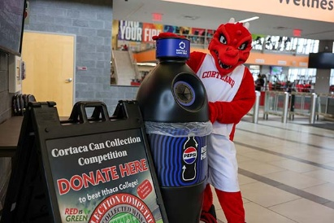
Red Dragons beat Bombers in Cortaca Can Collection
SUNY Cortland’s Green Reps inspired a friendly Cortaca environmental rivalry that saw winners all around. Through your efforts we not only won but raised over $80 for Cortland Reuses – way to go Red Dragons!


Campus named a top spot for bicyclists
SUNY Cortland is riding high after being named a Bicycle Friendly University (BFU) award winner by the League of American Bicyclists. Congratulations Drew Abrahms and the Cortland Bike Project!

SUNY Cortland adds AI-powered recycling assistant
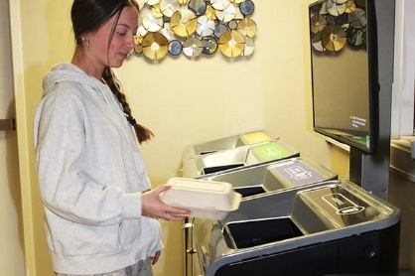
The Oscar Sort machine obtained through a PepsiCo, Inc., partnership uses AI to instantly assess user success.

Professor’s idea brings county together for Crown Table Feast

The free event looks to strengthen the community and fight food insecurity – a great example of sustainability and sustainable communities in action!

Sustainability Spotlight: Dr. Boyle and proper pest management
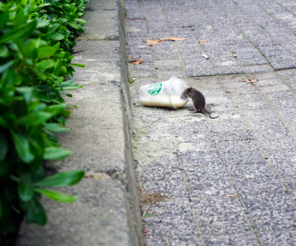
A new addition to KIG – the sustainability spotlight! Are you super passionate about sustainability and want to share your tips and trick about what you do on campus or at home? Do you want to shout someone out for their dedication to sustainability? Here is the place to do it. For each edition of the Sustainability Office's Keeping it Green Newsletter we will spotlight one person. It can be a student, faculty or staff. Submit your nominations at this link.
Our first Sustainability Spotlight is on Dr. Megan Boyle and proper pest management. With the transition to cooler temperatures, mice look for shelter indoors. Check out Dr. Boyle’s tips on how to safely and sustainably manage if mice make their way inside your home or apartment this winter.

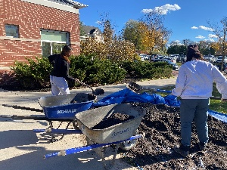
Keeping up with Sustainability
- Green Reps were among those who helped lay down compost and cardboard in preparation for a pollinator garden to be in the Child Care Center. Keep an eye out in the spring for more ways to get involved!
- Coming soon – Sustainability course attribute – for courses that have a sustainability focus. More details coming soon!
- The Sustainability Office is hiring! Interested in becoming a Green Rep to help create a culture of sustainability on campus through peer-to-peer engagement? Click here to apply.
Sustainability in the news
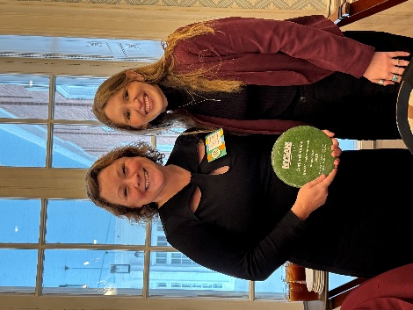
Cortland Standard - Megan Swing, energy and sustainability engagement coordinator was featured in a story about Cortland ReUse winning the NYSAR3 non-profit leadership award.
The Dragon Chronicle – read more about the history of Sustainability at SUNY Cortland
The Ithacan – read more about the ‘Cortaca Can Collection Competition’


Check us out on Instagram @cortland.greenreps !

